

Data Analytics Project: Railway Gauge Trends
Dataset Used: railway_gauges_1.csv

This document outlines a structured, end-to-end data analysis project based on railway gauge data. The project is divi Data Analytics Project: Railway Gauge Trends

This document outlines a structured, end-to-end data analysis project based on railway gauge data.

Dataset: Railway Gauge Data (Assumed to be in a CSV file)
Project Goal: To analyze historical trends and composition of different railway gauges (Broad, Metre, Narrow) over the years.
Modules Used:
The primary libraries/modules required for this project are:
- Pandas: For all data manipulation, filtering, aggregation, and feature engineering tasks.
- NumPy: Specifically for numerical calculations like yearly growth (np.diff).
- Visualization Library (e.g., Matplotlib): For generating all required plots (Line Graphs, Bar Charts, Pie Charts, Stacked Bar Charts).

🎯 Project Coverage

Category | Skills Covered
Data Preprocessing | Data Loading, Missing Value Handling, Type Conversion
Pandas Operations | Filtering, Selection, Aggregation, Feature Engineering
NumPy Calculations | Yearly growth calculation (np.diff)
Visualization | Line Graph, Bar Chart, Pie Chart, Stacked Bar Chart

Scenario 1: Basic Data Loading & Cleaning (🟢 Easy)

Description:
The railway gauge data is first loaded from a CSV file into a table using Pandas. Then we check if there are any missing values and fix them so the data stays clean and consistent. After that, important columns are converted into numeric format so we can easily analyze the data and create graphs later.

Task | Description
1. | Load the dataset into a Pandas DataFrame.
2. | Display the first 5 rows and column names to understand structure.
3. | Check for missing values and replace them with 0 (assuming missing values represent 0 km of track).
4. | Convert all relevant gauge columns (Broad, Metre, Narrow, Total) to numeric types (e.g., float64 or int64).

Conclusion:
The dataset was loaded and cleaned by fixing missing values and making sure all columns have the correct data types. This helps keep the data accurate and consistent. Now, the dataset is well organized and ready for further analysis in the next steps..

Scenario 2: Simple Visualization (🟢 Easy)

Description:
This scenario focuses on visualizing the growth of the railway network over time using a simple line graph. The relevant columns, Year and Total track length, are extracted from the dataset for analysis.

Task | Description
1. | Extract the Year and Total columns.
2. | Plot a line graph showing Total tracks over the Years.
3. | Add a descriptive title (e.g., "Growth of Total Railway Network Over Time") and X/Y axis labels.
4. | Identify whether the overall trend is increasing or decreasing and note the finding.

Graph:

The graph is a line plot with Year on the X-axis and Total railway track length on the Y-axis. Each data point is marked and connected to show changes over time. The chart clearly illustrates the progression of the railway network, making it easy to observe increases or decreases across years.

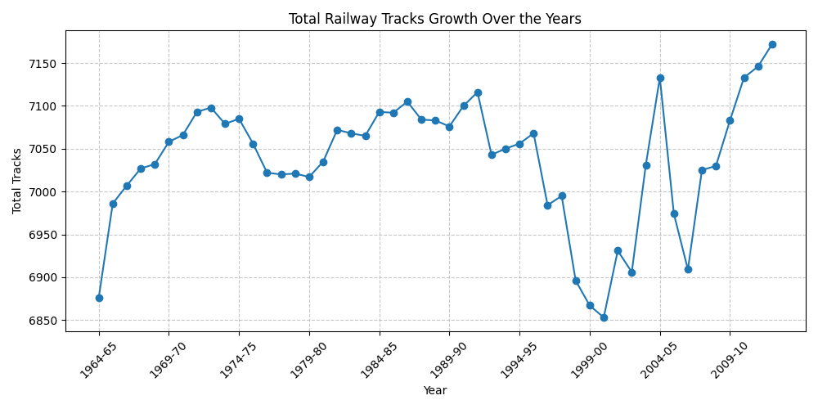

Conclusion:

The railway network has grown steadily over the years, with the total track length increasing overall. Even though there are a few small changes in between, the general trend shows continuous development. This clearly indicates that the railway system is expanding over time.

Scenario 3: Filtering + Bar Chart (🟡 Medium)
Description:
Filter the dataset for years after 2000, select the three gauges columns, and use a grouped bar chart to compare them and identify the dominant gauge.

Task | Description
1. | Filter the dataset to include only years after 2000.
2. | Select the Broad Gauge, Metre Gauge, and Narrow Gauge columns for the filtered data.
3. | Plot a grouped bar chart comparing the three gauges for the selected years.
4. | Add a legend and ensure proper labels for axes.
5. | Identify which gauge dominates in recent years (post-2000).

Graph:
The graph is a grouped bar chart where each year is represented on the X-axis, and the track length is shown on the Y-axis. For every year, three bars are displayed side by side representing Broad Gauge, Metre Gauge, and Narrow Gauge. The chart makes it easy to compare the contribution of each gauge over time.
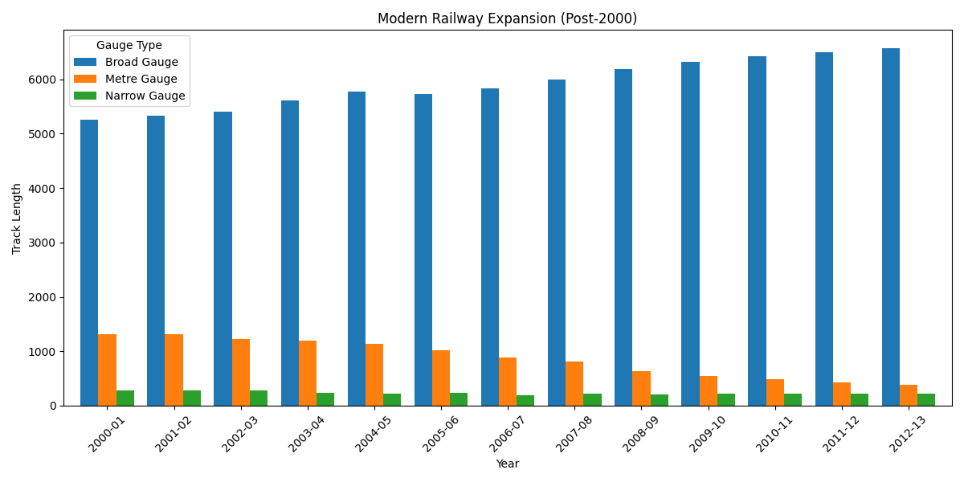
Conclusion:
Broad Gauge dominates after 2000, while Metre and Narrow Gauges decline, showing a shift toward modernization of the railway system.

Scenario 4: Feature Engineering + Pie Chart (🟡 Medium)

Description:

This scenario focuses on feature engineering to understand the overall contribution of different railway gauges. The total length of Broad Gauge, Metre Gauge, and Narrow Gauge is calculated across all years in the dataset. These aggregated values are stored in a new structure for easy analysis. A pie chart is then used to represent the proportion of each gauge type. This visualization helps in understanding the historical dominance of each gauge in the railway network.

Task | Description
1. | Calculate the total sum of each gauge (Broad Gauge, Metre Gauge, Narrow Gauge) across all available years.
2. | Create a new structure (Pandas Series or single-column DataFrame) holding these three total values.
3. | Plot a pie chart using this new structure to show the percentage contribution of each gauge type.
4. | Add percentage labels to the slices using autopct (e.g., '%.1f%%').
5. | Interpret which gauge contributes the most to the entire history of the railway network.

Graph:
The graph is a pie chart displaying the percentage contribution of Broad Gauge, Metre Gauge, and Narrow Gauge. Each slice represents one gauge type, with percentage labels shown using autopct. The Broad Gauge slice is slightly highlighted (exploded) to emphasize its contribution. The chart provides a clear visual comparison of how much each gauge contributes to the total railway network.

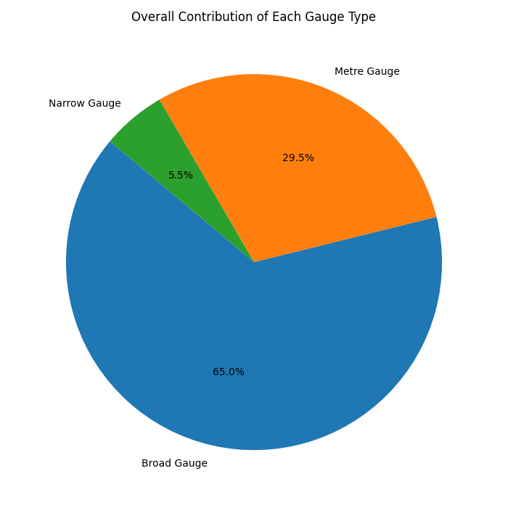

Conclusion:
The pie chart reveals that Broad Gauge contributes the largest share to the overall railway network. Its percentage is significantly higher compared to Metre and Narrow Gauges. Metre Gauge holds a smaller portion, while Narrow Gauge contributes the least. This indicates that, historically, Broad Gauge has been the most important component of the railway system. The analysis highlights the dominance and long-term preference for Broad Gauge infrastructure.

Scenario 5: Advanced Analysis + Multiple Graphs (🔴 Hard)

Description:
This scenario focuses on advanced analysis of railway data by combining feature engineering, numerical computation, and multiple visualizations. New percentage-based columns are created to understand the composition of each gauge relative to the total network. NumPy is used to calculate yearly growth, helping identify trends and fluctuations. Multiple graphs, including line plots and stacked bar charts, are used to present both proportional and absolute data. This approach provides a deeper understanding of long-term railway development patterns.

Task | Description
1. | Create new columns for percentage composition relative to Total tracks for each year: % Broad Gauge, % Metre Gauge, and % Narrow Gauge.
2. | Use the NumPy function np.diff to calculate the yearly growth (change) of the Total tracks column.
3. | Plot: a) A single Line Graph showing the trend of all three percentage composition columns (% Broad Gauge, % Metre Gauge, % Narrow Gauge) over the years. b) A Stacked Bar Chart showing the raw composition of the three gauges (Broad, Metre, Narrow) over time.
4. | Highlight/Identify: a) The year(s) with the highest yearly growth in Total tracks. b) Any specific decade or period showing a significant decline in any particular gauge.
5. | Final Conclusion: Based on the percentage composition line graph, provide a conclusion to the question: "Is the railway system shifting towards a single dominant gauge?"

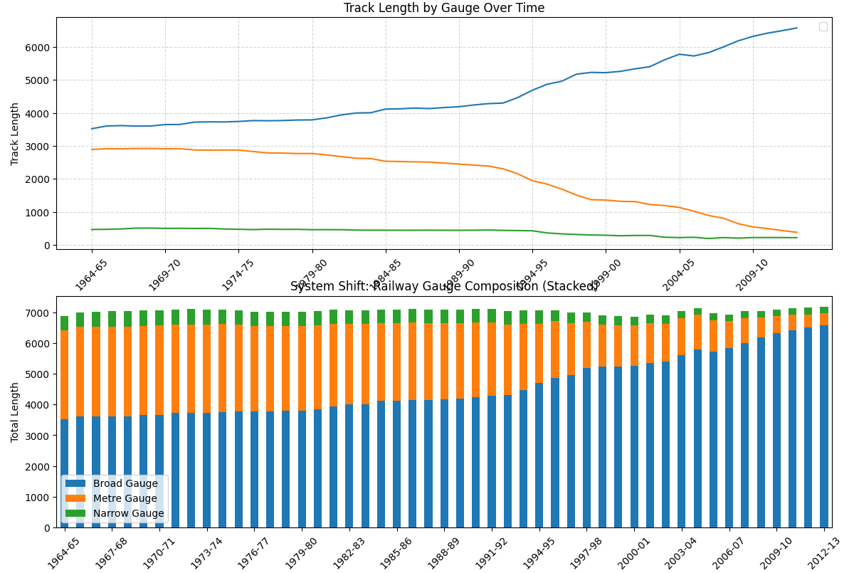
Conclusion:
ded into five scenarios, increasing in difficulty from basic data handling to advanced analysis and visualization, ensuring comprehensive skill coverage.

Final Conclusion:
The analysis of railway gauge data shows a clear growth in the overall railway network over the years. Broad Gauge has become the dominant type, showing continuous increase, especially after 2000. In contrast, Metre and Narrow Gauges have gradually declined, indicating reduced usage. The visualizations and calculations highlight a steady shift toward standardization and modernization. Overall, the railway system is expanding with a strong focus on Broad Gauge development.
What you have learned
In this project, I learned how to take raw data from a file and turn it into something meaningful. I understood how to clean the data, fix missing values, and work with only the required parts. I also learned how to use graphs to make the data easier to understand. By doing this, I was able to see patterns like which gauge is increasing and which is decreasing. Overall, this project helped me understand how data can be analyzed and explained in a simple way.

